# Overview

The Doc Loader Bot (whether run by schedule or manually) aims to automate the compiling, checking and file management process for uploading datasheets.

The Bot is created and managed by;

*Joe Martin*

[*joe.martin@rs-components.com*](mailto:joe.martin@rs-components.com?subject=Regarding%20Doc%20Loader%20Bot)

# How to run manually

If the automated task does not run or is not set-up, you can the program manually from the Spare Computer.

1. Open the shortcut; “Main.py” from the Desktop by double left-clicking.
2. A terminal should open immediately as shown:
3. Wait for the terminal to close. This should take anywhere from a few to 30 seconds depending on number of load files
4. Navigate to: here
5. You should see the new folder created with the current date, followed by a number showing the iterations ran that day. For example, #3 is the third time the program has been run that day
6. The folder created should contain the original load file(s), the log file, and the compile file.
7. If all these files are present, you may continue to load the compile file onto Doc Loader as normal

If a file is not present, or the folder not created, please navigate to: here and email a copy of the Log file to: [joe.martin@rs-components.com](mailto:joe.martin@rs-components.com)

# Understanding the Log File:

The Log File is used to track what the program does, in case or errors/failure, to see how many articles have been loaded, as well as which load files have been loaded.

Here is an example of a Log file:

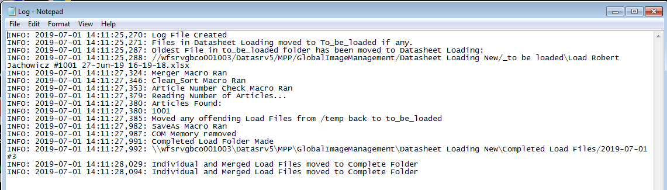

You will not need/want most of the information in the Log file, except possibly the number of articles compiled and the name of the Completed folder created. These can be seen here:



**Please note:** The number of articles found is always +1 to the actual number. For example, 1000 articles found will display as 1001, just as load files do.

With program updates, new information may be added into the Log File.

**You can always see if the program executed successfully if the Log file contains “Program Ended Successfully” at the end.**

# Priority Loads

If you need to make priority loads, or for any other reason not be able to use the bot, simply follow the usual old process by placing the Load Files in the Datasheet Loading folder, and using the merging spreadsheet, “Part-Manual-Merge” in from the folder here.

# FAQ

*What is the maximum number of load compiles per day?*

Four separate compiles. Each compile can have an unlimited number of Load files. This can be changed by request.

*What is the maximum number of articles per compile?*

1000. This can be changed by request (email at top of document).

*Something isn’t right or is behaving strangely…*

Please email me, the more detail the better and a copy of the Log file if possible.

*There is a Load file of over 1000 articles, what should I do?*

As normal, you will need to split the file. Load files should have a maximum of 950 ish.